SMART INDIA HACKATHON · PROBLEM STATEMENT 26154
Pramaan AI
प्रमाण · Content you can prove.

Project document: problem, solution, users, use cases, features, technology and installation
Problem statement: Gen AI Platform for Automated Content Transformation
Organisation: National Technical Research Organisation (NTRO)
Theme: Blockchain & Cybersecurity · Category: Software
Team: [TEAM NAME] · Version: 1.0, 30 September 2026
This document explains everything about the project in simple words, so every team member, mentor and judge can understand it without a technical background.

Contents
1. The whole project on one page
2. The problem, clearly explained
3. Our solution: Pramaan AI
4. Who uses Pramaan AI (roles and access)
5. Use cases: how each person uses the app
6. Complete list of features
7. App screens (design)
8. Technology stack
9. How Pramaan AI is downloaded, installed and used
10. Security and privacy
11. Build plan and demo
12. Honest limitations and future roadmap
13. Simple glossary

1. The whole project on one page

The problem
Security agencies like NTRO receive long reports every day, for example about a cyber attack. From each report they must write many different things: an advisory, a short summary for senior officers, slides, social media posts, an infographic and a video script. Today this is done by hand. It is slow, it needs expert writers, the facts often do not match between versions, and tools like ChatGPT cannot be used because secret data would go to foreign servers.

Our solution
Pramaan AI is an app installed on the organisation’s own computer. It works fully offline using Indian AI models. The user uploads a report once, ticks the formats they need, and the app creates all of them in minutes, in 22 Indian languages plus English. A reviewer approves the outputs and signs them with an official digital signature. Every document gets a QR code, so anyone can check whether it is genuine or fake.

What makes it different
- Fully offline: secret reports never leave the computer.
- Indian AI: Sarvam (Bengaluru), BharatGen (IIT Bombay) and AI4Bharat (IIT Madras).
- Truthful: every sentence can be traced back to the original report, and unsupported sentences are flagged.
- Safe to publish: sensitive details such as internal IP addresses are hidden automatically in public posts.
- Impossible to fake: signed documents carry a QR code, and a public “Is this real?” page catches fake alerts.

Who uses it
Operators create content, Reviewers approve and sign it, Admins manage the system, and the Public can verify documents without logging in.

How it is installed
One command in the terminal installs the app and downloads the Indian AI models once. For secret offices with no internet, everything comes on a USB drive. After that, the app opens in a normal web browser but runs entirely on the user’s own computer.
One-line pitch: One report in → every format out: offline, accurate, in every Indian language, and impossible to fake.

2. The problem, clearly explained

2.1 What organisations deal with every day
Government and security organisations constantly receive information in many forms: threat reports, news articles, research papers, policy documents, advisories, incident reports and announcements. This information is useful only when it reaches the right people, in the right form, quickly.
The same piece of information usually has to be communicated to many different audiences. Each audience needs a different format, tone and level of detail:
Audience | What they need | Example format
IT and security teams | Exact technical details and clear steps | Structured advisory
Senior officers | The key points in two minutes, and the decision needed | Executive summary
Meetings and briefings | A visual story with talking points | Presentation with speaker notes
The general public | Simple warnings and what to do | LinkedIn post, X thread, infographic
Awareness campaigns | Something people will watch | Video script with storyboard
Citizens across India | Information in their own language | Any of the above in Hindi, Tamil, Bengali…

2.2 A real-life example
Imagine a ransomware attack is locking computers in hospitals across several states. A 30-page technical report arrives in the morning. Before the end of the day, the team must produce:
- a formal advisory for hospital IT teams,
- a one-page summary for senior officers,
- a presentation for an emergency meeting,
- social media posts to warn the public,
- an infographic for quick sharing,
- a video script for an awareness campaign,
- and versions of all of these in several Indian languages.
Done by hand, this can take a team one to two days. During a cyber attack, every hour of delay means more damage.

2.3 Why the current way fails
Problem | What happens | Why it matters
Slow | Each format is written separately by hand | Warnings reach people late
Needs experts | Only skilled writers with domain knowledge can do it | Small teams get overloaded
Facts do not match | One version says 42 hospitals, another says 24 | People lose trust in official information
Language gap | Most material is made only in English | Many citizens are left out
Fake advisories | Criminals send fake “government alerts” with scam links | People are tricked into sharing OTPs or clicking malware

2.4 Why ChatGPT-style tools are not the answer
- Data leaves the country: online AI tools send the document to servers run by foreign companies. For secret or sensitive reports this is not allowed.
- AI can make things up: these tools sometimes write confident but wrong facts (called “hallucinations”). In official communication this is dangerous.
- No proof: a document written by AI cannot prove where it came from or whether someone changed it later.
- Weaker in Indian languages: many global tools are much better in English than in Indian languages.

2.5 What NTRO has asked for
NTRO wants an AI-powered content transformation platform. In simple words:
- A dashboard where an operator gives source content: text, documents, articles, reports, prompts, images, videos or other information.
- The operator selects one or more output types: video package, LinkedIn post, Twitter/X post, advisory, infographic, executive summary, presentation.
- The operator can control settings such as target audience, tone, language, level of detail, objective and style.
- The platform understands the content and creates every selected output from the same source.
Deliverables for evaluation: source code link, README with setup instructions, architecture document (maximum 2 pages), demo video (maximum 2 minutes) and technical presentation (maximum 5 slides).

3. Our solution: Pramaan AI

3.1 In one sentence
Pramaan AI is an offline app, powered by Indian AI, that turns one report into every format an organisation needs, in 22 Indian languages, while hiding secrets, proving every fact and making every document impossible to fake.

3.2 Why the name
Pramaan (प्रमाण) means “proof” or “evidence”. It describes exactly what makes the app special: every sentence is proved against its source, and every document can be proved genuine with its QR code. The tagline is “Content you can prove.”

3.3 How it works, in 8 steps
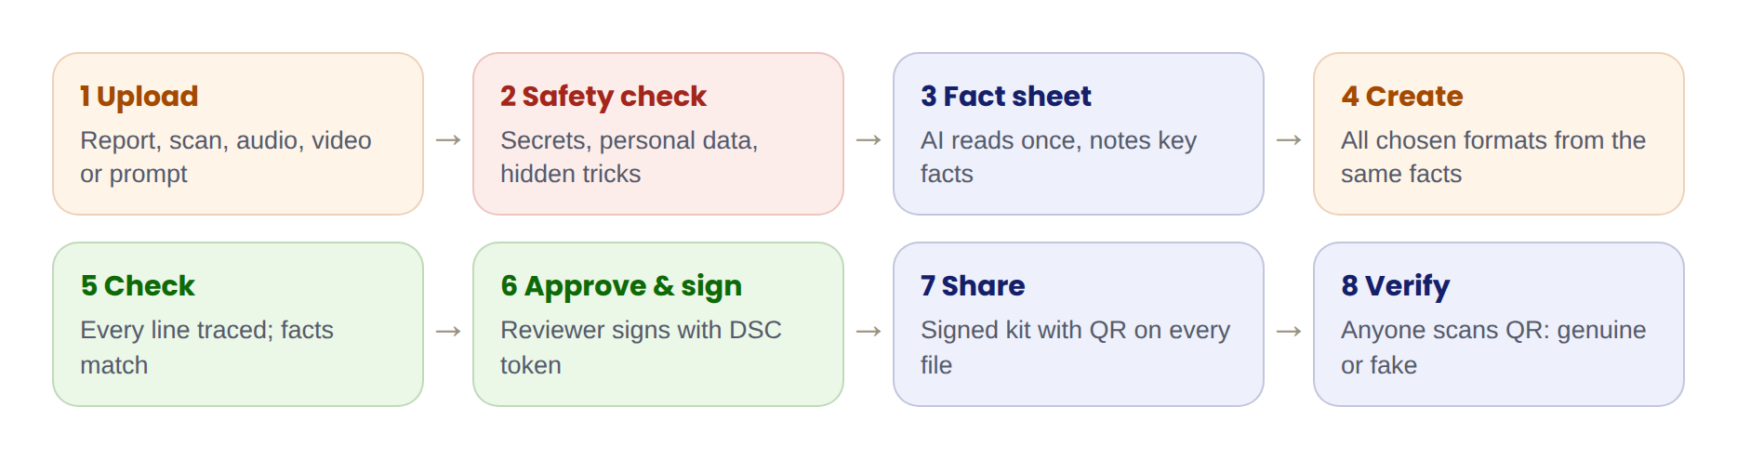
Figure 1: The journey of one report through Pramaan AI
- Upload. The operator gives a report, document, scanned page, image, audio or video, or simply types or speaks a request.
- Safety check. Before anything else, the app looks for secret markings (like “RESTRICTED”), personal data (like Aadhaar numbers) and hidden tricks meant to fool the AI. It suggests a sharing level (TLP).
- Fact sheet. The AI reads everything once and writes down the key facts, numbers, dates, affected systems and recommended actions.
- Create. Every selected output is written from that one fact sheet, so all versions say the same thing. Short outputs appear first.
- Check. The app traces every sentence back to the source, checks that facts match across all outputs, and checks public posts for panic-causing or unverified wording.
- Approve and sign. A reviewer checks the work and signs it with a Class 3 digital signature (DSC) token.
- Share. The signed files are saved as a Campaign Kit, each with its own QR code.
- Verify. Anyone who receives a document can scan the QR code and see “Genuine” or “Not genuine”.

3.4 The six ideas that make Pramaan AI special
Idea | What it means in simple words | Why judges will care
1. Fully offline | The whole app, including the AI, runs on the organisation’s own computer. No internet is needed. | Secret data never leaves the building. Perfect for a security agency.
2. Indian AI | Uses models built in India: Sarvam 30B, BharatGen Param2 and AI4Bharat’s language tools. | Supports the IndiaAI Mission and Atmanirbhar Bharat.
3. One fact sheet, many outputs | The AI reads the report once and writes every output from the same facts. | No more “42 hospitals” in one version and “24” in another.
4. Every line traced | Click any sentence to see where it came from. Unsupported sentences turn yellow. | Solves the biggest fear about AI: making things up.
5. Safe for the public | Sensitive details are hidden automatically in public posts, and TLP sharing labels are applied. | Prevents accidental leaks.
6. Signed and verifiable | Approved documents are digitally signed, recorded in a tamper-proof record book and carry a QR code. | Fake government advisories become easy to catch.

3.5 How we meet every NTRO requirement
NTRO asked for | How Pramaan AI does it
Dashboard for the operator | Operator dashboard and a 3-step “New transformation” flow
Input as text, documents, articles, reports, prompts | Upload PDF, Word, text, saved web pages; type or speak a prompt
Input as images and videos | Scanned pages read with offline OCR; audio and video turned into text offline
Select one or more output types | 7 output tiles; select any combination
Video: script, storyboard, scenes, narration, subtitles, visuals | Full video package plus a narrated preview video with Indian voices and subtitle files
LinkedIn post, Twitter/X post or thread | Both, with character limits checked and sensitive details hidden
Structured advisory | CERT-In style advisory with severity, indicators and actions
Infographic content and layout | Key messages, three layouts and a finished PNG image
Executive summary | One-page briefing with “decision needed”, plus an audio version
Presentation slides and speaker notes | Complete PowerPoint deck with notes for every slide
Control audience, tone, language, detail, objective, style | All six controls, plus sharing level and letterhead
Multiple outputs from the same source | All outputs come from one fact sheet, in parallel

4. Who uses Pramaan AI
Pramaan AI has three kinds of logged-in users and one kind of public visitor. Each logged-in role has its own colour in the app, taken from the Indian flag, so users always know which workspace they are in.
Role | Colour | Who they are | What they do
Operator | Saffron | Analysts and communication staff | Upload sources, choose outputs, edit drafts, send work for review, create emergency alerts
Reviewer | Green | Senior officers who hold a DSC token | Check outputs, add comments, approve and sign, send work back, withdraw old records
Admin | Navy blue | The system manager | Set up the app, manage users, templates, security rules, AI models, updates and the public verify page
Public (guest) | None | Any citizen, hospital, company or journalist | Only verify documents: scan a QR code, upload a file or paste a message. No login, no access to any data

4.1 What each role is allowed to do
Permission | Operator | Reviewer | Admin | Public
Verify a document (QR, file or message) | Yes | Yes | Yes | Yes
Create and edit content | Yes | No | No | No
Use emergency mode | Yes | Yes | No | No
Approve and sign | No | Yes | No | No
Withdraw (revoke) signed records | No | Yes | Yes | No
Manage users and templates | No | No | Yes | No
Change security rules | No | No | Yes | No
Update the public verify page | No | No | Yes | No

4.2 How the public reaches Pramaan AI without an account
The public never opens the main app. Instead, there is a small separate verification page (for example verify.[organisation].gov.in) hosted on a government server such as NIC or MeghRaj. It holds only the organisation’s public certificate and the list of withdrawn documents. It contains no reports, no names and no AI.
When a citizen scans the QR code on a document, the phone opens this page. The QR code itself carries the document’s fingerprint and digital signature, and the phone checks it against the public certificate. The Admin keeps the page up to date by carrying a small signed update file from the offline office computer on a USB drive. Data only ever flows out of the office, never in.

Figure 2: One-way flow from the offline office computer to the public verify page

5. Use cases: how each person uses the app
Each use case below is a short, real-life story showing who uses the app, what situation they are in, what they do step by step, and what they get. The sample names (Priya, Arjun, Kavya, Rahul, Meera) are used across the whole design.

5.1 Operator use cases

O1. Turning a threat report into a full advisory kit
Who: Priya, Operator, cyber operations team
Situation: A 30-page report on a ransomware attack against hospitals arrives at 9 am. Priya needs an advisory, a summary, slides and public posts in English, Hindi and Tamil.
What they do:
- Opens New transformation and uploads the PDF.
- Reads the safety check: it found a “RESTRICTED” marking and 6 internal IP addresses, and suggests TLP:AMBER. She accepts.
- Picks the Cyber advisory kit, adds the X thread, selects English, हिन्दी and தமிழ், audience “IT and security teams” and tone “Formal”.
- Clicks Generate. The summary and X thread appear in about 20 seconds; the rest follow within minutes.
- Opens the advisory, clicks “42 hospitals…” and sees the matching line on page 4 of the report.
- Clicks Send for review.
Result: About 30 minutes of work instead of 1–2 days. All versions state the same facts, and the public posts do not contain the internal IP addresses.

O2. A public awareness campaign
Who: Priya, Operator
Situation: A phishing scam using fake electricity bills is spreading. The goal is to warn ordinary citizens.
What they do:
- Uploads the incident note and chooses the Public awareness kit (LinkedIn post, X thread, infographic, video package).
- Sets audience “General public”, tone “Calm”, style “Simple”.
- Previews the posts in the Social posts screen, where the character limits are already checked.
- Picks the “Steps” layout for the infographic and downloads the PNG.
- Listens to the narrated video preview in Hindi and adjusts one scene’s narration.
Result: A complete, consistent campaign in several languages, with a QR code on the infographic so people can check it is real.

O3. Emergency alert in all 22 languages
Who: Priya, Operator (on emergency duty)
Situation: Scam links pretending to be hospital bills are spreading fast. People need a warning right now, in their own languages.
What they do:
- Clicks Emergency alert on the dashboard.
- Chooses “Cyber fraud”, severity “Warning”, area “All states”, and writes one short English message (under 160 characters).
- The app instantly shows the alert in all 22 languages with voice announcements, and confirms the wording will not cause panic.
- Clicks Send for fast-track approval. Any on-duty reviewer is notified at once.
Result: A signed, multilingual alert with voice versions within minutes, ready for SMS, radio or social media.

O4. Combining several different sources
Who: Priya, Operator
Situation: She has a PDF report, a photo of a printed circular and a Hindi voice recording of a briefing call.
What they do:
- Drags all three into the upload screen.
- The app reads the PDF, uses offline OCR on the photo, and turns the Hindi speech into text with IndicConformer.
- All three are merged into one fact sheet.
Result: Outputs that combine everything, with each sentence still traceable to the exact source it came from.

O5. Starting from a prompt or voice, with no document
Who: Rahul, Operator
Situation: He has no report, only an idea: explain the new data protection rules to students.
What they do:
- Chooses Text or prompt or presses Speak and describes what he needs in Hindi.
- Picks outputs and settings as usual.
Result: Draft outputs created from his instructions. Because there is no source document, the app marks them clearly as needing a careful review.

O6. Fixing a sentence the source does not support
Who: Priya, Operator
Situation: The AI wrote “Attackers are believed to be demanding payment in cryptocurrency”, but the report never says this.
What they do:
- Sees the sentence highlighted in yellow with the note “1 sentence not found in source”.
- Chooses Remove, or Keep as analyst note if her own knowledge supports it.
Result: No unsupported claim goes out silently. The reviewer sees exactly what was changed.

O7. Updating when the incident grows (version 2)
Who: Priya, Operator
Situation: Two days later, a new report says 57 hospitals in six states are now affected.
What they do:
- Adds the new report to the same job.
- Opens Version compare: added text in green, removed text in red, plus a summary (“42 → 57 hospitals, 5 → 6 states, +1 action”).
- Regenerates all outputs from version 2 and sends it for review.
Result: A clear, trackable update. The old signed version is marked “Replaced by #0142” in the records.

O8. Watch folder: drafts ready before you arrive
Who: Priya, Operator
Situation: Reports arrive at all hours in a shared folder.
What they do:
- Turns on Watch folder, points it to the incoming folder, picks a default kit and languages.
- Each morning she opens the ready drafts, checks them and sends them for review.
Result: Routine reports are drafted automatically. Nothing is ever published without a human approving it.

O9. Work sent back by the reviewer
Who: Priya, Operator
Situation: Arjun sent back the flood advisory because a district name in the Tamil version was wrong.
What they do:
- Sees “Sent back” on her dashboard with Arjun’s comments on the exact lines.
- Fixes the lines (or regenerates that part) and resends.
Result: Mistakes are fixed before release, and the whole conversation is kept in the audit trail.

5.2 Reviewer use cases

R1. Reviewing and signing a kit
Who: Arjun, Reviewer (holds a Class 3 DSC token)
Situation: Priya’s ransomware kit is waiting in his review queue.
What they do:
- Opens the kit and reads the automatic checks: sentences traced, facts matching, sensitive details hidden, safe public wording, no hidden tricks.
- Reads each output and adds comments where needed.
- Plugs in his DSC token, enters his PIN and confirms he has reviewed the work.
- Clicks Sign 21 files.
Result: Every file is signed, gets a QR code and is recorded in the record book. Priya is notified that the Campaign Kit is ready.

R2. Fast-track approval of an emergency alert
Who: Arjun, Reviewer on duty
Situation: An emergency alert arrives, marked in red at the top of his queue.
What they do:
- Opens it, checks the English message and a few translations, listens to one voice announcement.
- Signs it immediately.
Result: Approval in minutes, without skipping the human check.

R3. Sending work back with notes
Who: Arjun, Reviewer
Situation: The Tamil flood advisory names a district that is not in the English source.
What they do:
- Chooses reasons (“Facts need checking”, “Language quality”).
- Adds comments on the exact lines and a short note to Priya.
- Clicks Send back.
Result: Clear, specific feedback. Nothing wrong is signed.

R4. Withdrawing an old advisory
Who: Arjun, Reviewer
Situation: An older VPN advisory is now wrong and must not be trusted any more.
What they do:
- Opens Signed records, finds the record and clicks Revoke.
- The Admin includes it in the next public page update.
Result: Anyone who scans the old QR code now sees that it has been withdrawn.

5.3 Admin use cases

A1. Installing and setting up for the first time
Who: Kavya, Admin
Situation: A new office wants to start using Pramaan AI on a computer that has no internet.
What they do:
- Runs the installer from the USB drive.
- The first-time setup checks memory, graphics card and disk space, and confirms the Indian AI models are installed.
- Creates the first Admin account and saves the 8 recovery codes offline.
- Adds organisation details, the letterhead and the signing certificate.
Result: The app is ready in about 5 minutes after installation.

A2. Approving a new user
Who: Kavya, Admin
Situation: Rahul has filled in the “Request access” form.
What they do:
- Sees “2 access requests” on the Admin overview.
- Checks his details, confirms the role (Operator) and clicks Approve.
Result: Rahul can now sign in. The approval is recorded in the audit trail.

A3. Adding a reviewer who can sign
Who: Kavya, Admin
Situation: Meera is joining as a Reviewer and has a Class 3 DSC token.
What they do:
- Opens Add user, fills in her details, picks Reviewer, turns on “Holds a Class 3 DSC token” and “Emergency duty”.
- Shares the temporary password with her in person.
Result: Meera can review and sign from her first day.

A4. Investigating something suspicious
Who: Kavya, Admin
Situation: The system blocked a hidden instruction inside an uploaded PDF.
What they do:
- Opens the Audit trail, filters by “Security” and sees who uploaded the file and when.
- Exports the signed log for the investigation team.
Result: A complete, tamper-proof history of what happened.

A5. Running on a weaker computer
Who: Kavya, Admin
Situation: A branch office has computers with only 16 GB of memory.
What they do:
- Opens AI models and switches to Lite mode (Param2 17B).
Result: The app works on smaller computers, with slightly simpler writing.

A6. Keeping the official look
Who: Kavya, Admin
Situation: Outputs must use the organisation’s letterhead and slide style.
What they do:
- Uploads the letterhead in Templates and sets it as the default.
Result: Every document looks official automatically.

A7. Tightening security rules
Who: Kavya, Admin
Situation: A new classification word must always be detected.
What they do:
- Opens Security and policies, adds the word, and checks the sharing rules table.
Result: The scanner catches the new word in every future upload.

A8. Updating the public verify page
Who: Kavya, Admin
Situation: Several documents were signed or withdrawn this week.
What they do:
- Opens Public verify page, exports the signed update file to USB, and uploads it on the public server.
Result: The public always sees correct “genuine” and “withdrawn” results. Nothing from the internet touches the office computer.

A9. Updating the app and keeping backups
Who: Kavya, Admin
Situation: A new version arrives on a USB drive.
What they do:
- Opens Updates and backup. The app checks the update’s signature, backs everything up and installs it.
Result: Safe updates with no internet, and encrypted backups every night.

A10. Checking the record book
Who: Kavya, Admin
Situation: She wants to be sure no signed record has been secretly changed.
What they do:
- Opens Record book and clicks Check the whole chain.
Result: “Chain intact · 142 of 142 entries verified” in about 2 seconds.

5.4 Public use cases

P1. Checking a real advisory
Who: A hospital IT officer
Situation: An advisory arrived by email. Is it really from the agency?
What they do:
- Scans the QR code with the phone camera.
- The verify page opens (no app, no login).
Result: “Genuine”, with the issuing office, signer, date and “not changed since signing”.

P2. Catching a fake WhatsApp message
Who: A citizen
Situation: A forwarded “URGENT GOVT CYBER ALERT” asks for an OTP within 1 hour.
What they do:
- Opens the verify page and pastes the message.
Result: “Not genuine”: no signature, suspicious link, asks for an OTP, pressure words. The page shows the national cybercrime helpline 1930.

P3. Spotting an edited copy
Who: A journalist
Situation: Someone changed one number in a real advisory and shared it.
What they do:
- Uploads the file on the verify page.
Result: The fingerprint no longer matches the signature, so the result is “Not genuine: changed after signing”.

P4. Seeing that an advisory was withdrawn
Who: A company security team
Situation: They are still following an old advisory.
What they do:
- Scan its QR code.
Result: “Withdrawn” with the date, so they know to look for the newer version.

5.5 Other organisations that can use Pramaan AI
Organisation | How they would use it
NTRO, NCIIPC, CERT-In, state CERTs | Threat advisories, briefings and public warnings
Police cyber cells | Scam warnings in local languages, awareness posts and videos
Disaster management (for example NDMA) | Flood, cyclone and heatwave alerts in all 22 languages with voice announcements
Health departments | Health advisories, outbreak updates and public awareness
Ministries and departments | Explaining new policies and rules to officers and citizens
Universities and training bodies | Turning research papers into summaries, slides and explainers

6. Complete list of features
Features are grouped by what they help with. Each one says what it does and why it matters.

A. Input: what the user can give
Feature | What it does | Why it matters
Text or prompt | Paste text or describe what you need | Works even without a document
Documents | PDF, Word, text and saved web pages | Covers most official material
Scanned pages and images | Reads text from images offline (OCR), including Indian scripts | Many government papers are scanned
Audio and video | Turns speech into text offline | Briefing calls and videos become usable
Voice instructions | Speak in your own language | Faster and more inclusive
Multiple sources | Up to 5 sources merged into one fact sheet | Real incidents rarely come from one file

B. The AI engine
Feature | What it does | Why it matters
Fact sheet | The AI reads once and writes down the key facts | All outputs agree with each other
7 output types | Advisory, executive summary, presentation, video package, infographic, LinkedIn post, X thread | Everything NTRO asked for
Many at once | Pick any combination; all are made from the same source | One click instead of seven jobs
Kits | Ready-made sets like “Cyber advisory kit” | Saves time on common jobs

C. Settings the user controls
Feature | What it does | Why it matters
Audience, tone, objective, style | For example: senior officers, calm, warn and instruct, official | The same facts, written for the right reader
Level of detail | Short, medium or detailed | Fits the time the reader has
Language | English plus 22 Indian languages | Reaches every citizen
Sharing level (TLP) | Red, Amber, Green or Clear | Controls who may see each output
Letterhead and template | Organisation’s official look | Outputs look official

D. Trust and accuracy
Feature | What it does | Why it matters
Click-to-source | Click any sentence to see the matching line in the source | Anyone can check the AI’s work
Unsupported-line warning | Sentences not found in the source turn yellow | Catches made-up facts
AI self-check | The AI re-reads its output against the fact sheet and fixes errors | Fewer mistakes before a human even looks
Fact match across outputs | Numbers, dates and names must agree everywhere | Consistent official communication
Quality score | Scores for tracing, readability, format rules and tone | Quick view of how good each output is
“AI-assisted, human-approved” label | Printed on every document | Honest and transparent

E. Security and privacy
Feature | What it does | Why it matters
Fully offline | No internet needed; nothing leaves the computer | Safe for secret material
Sensitive information scanner | Finds Aadhaar, PAN, phone numbers, emails, IP addresses, passwords and classification words | Warns before anything is shared
Audience-based auto-hiding | Internal outputs keep details; public outputs hide them automatically | Prevents accidental leaks
Hidden-instruction shield | Catches text inside files that tries to control the AI (prompt injection) | Stops attackers from tricking the AI
Encrypted storage | Database and files are locked with encryption | A stolen laptop reveals nothing
Roles and audit trail | Each person sees only what they need; every action is recorded | Accountability

F. Anti-fake protection
Feature | What it does | Why it matters
Digital signature (DSC) | Reviewers sign with an Indian Class 3 DSC USB token | Legally recognised official seal
QR code on every file | Links the document to its signature | Anyone can check it
Record book | Each signed document’s fingerprint is linked to the one before it | Any secret change is exposed
Withdraw (revoke) | Mark old documents as withdrawn | People stop trusting outdated advice
“Is this real?” checker | Checks QR codes, files and pasted messages for signatures and scam signs | Catches fake alerts

G. Indian languages and voice
Feature | What it does | Why it matters
22 Indian languages | Translation with IndicTrans2 | National reach
Indian voices | Narration and audio versions with Indic Parler-TTS | For videos, radio and visually impaired users
Voice input | Speak instead of typing | Easier for everyone

H. Smart extras
Feature | What it does | Why it matters
Emergency mode | Short alerts in all 22 languages with voice, fast-track review | Minutes instead of hours in a crisis
Public-release safety check | Flags panic-causing, offensive or unverified wording | Protects public trust
Cyber-intelligence extractor | Pulls CVE numbers, IP addresses and file fingerprints into a table | Advisories are ready for IT teams
Built-in editor | Quick buttons: Shorter, More formal, Simpler, Regenerate part | Easy fine-tuning
Version compare | Version 2 with changes highlighted | Clear updates as incidents grow
Watch folder | New reports in a folder are drafted automatically | Saves time on routine work
Campaign Kit | All files and languages in one signed package | Easy to share with other departments

I. Administration
Feature | What it does | Why it matters
Users and access requests | Approve, add, lock users; see what each role can do | Controlled access
AI models and performance | Full or Lite mode, model status, speed settings | Works on different computers
Templates | Letterheads, advisory, slide and infographic designs | Consistent official look
Security and policies | Scanner rules, sharing rules, encryption, certificates, sessions | One place to control safety
Public verify page settings | Export the signed update file for the public page | Keeps public checks correct
Offline updates and backup | Signed updates from USB; nightly encrypted backups | Safe maintenance without internet

J. Speed
Feature | What it does | Why it matters
Efficient Indian AI | Sarvam 30B uses only a small part of its “brain” for each word | Fast on normal computers
Read once, reuse | The fact sheet is reused for every output | Much less waiting
Quick mode and think mode | Deep thinking only for the fact sheet | Short posts are very fast
Live typing and short outputs first | Text appears as it is written | Users see progress immediately
Remember past results | The same file again gives instant results | No repeated work

7. App screens (design)
The full design has 46 screens, covering every role from the splash screen to the last settings page. They are saved in the “Designs” folder next to this document, in three forms:
- Screen images: one picture per screen, grouped in folders by role.
- All screens PDF: every screen in one file, easy to share.
- Clickable prototype: open “index.html” in a web browser and click through the app. Buttons and menus move between screens.
No. | Screen | Used by | What it shows
01 | Splash screen | Everyone | Logo, name, tagline
02 | Language selection | Everyone | All 22 Indian languages plus English
03 | Sign in | Staff | Password or DSC token sign-in
04 | Sign up (request access) | New staff | Request an Operator or Reviewer account
05 | Forgot password | Staff | Reset through the Admin or a recovery code
06 | Access request pending | New staff | Status of the request
07 | First-time setup | Admin | Computer check, models, first Admin
08 | Operator dashboard | Operator | Jobs, stats, items needing attention
09 | New transformation 1: Add sources | Operator | Upload, kits, speak
10 | New transformation 2: Safety check | Operator | Sensitive items, TLP, hidden tricks
11 | New transformation 3: Outputs and settings | Operator | Choose outputs, languages and settings
12 | Generating | Operator | Fact sheet, progress, live preview
13 | Results: advisory with source trace | Operator | Click-to-source, yellow warnings, quality score
14 | Results: presentation | Operator | Slides, notes, download
15 | Results: video package | Operator | Scenes, narration, voices, subtitles
16 | Results: social posts | Operator | LinkedIn post and X thread
17 | Results: infographic | Operator | Layouts, key messages, PNG
18 | Results: executive summary | Operator | One page, audio version
19 | Campaign kit download | Operator | Signed package of all files
20 | My jobs | Operator | History with filters
21 | Version compare | Operator | Version 1 vs version 2
22 | Emergency alert | Operator | 22 languages with voice
23 | Watch folder | Operator | Automatic drafts
24 | Reviewer dashboard | Reviewer | Review queue and DSC status
25 | Review a kit | Reviewer | Checks and line comments
26 | Sign with DSC | Reviewer | Token, PIN, confirmation
27 | Signed successfully | Reviewer | QR, fingerprint, next steps
28 | Send back with notes | Reviewer | Reasons and comments
29 | Signed records | Reviewer | Archive and revoke
30 | Admin overview | Admin | Health, requests, security events
31 | Users and access | Admin | Users, requests, permissions
32 | Add or edit user | Admin | Role, DSC, temporary password
33 | Audit trail | Admin | Every action, tamper-proof
34 | AI models and performance | Admin | Full/Lite mode, models, speed
35 | Templates | Admin | Letterheads and designs
36 | Security and policies | Admin | Scanner, sharing rules, encryption
37 | Record book | Admin | Chain of signed fingerprints
38 | Public verification page | Admin | One-way update to the public page
39 | Updates and backup | Admin | USB updates, backups
40 | Notifications | All staff | Updates about jobs
41 | Profile and settings | All staff | Language, accessibility, password
42 | Is this real? (phone) | Public | Three ways to check
43 | Scanning QR (phone) | Public | Camera view
44 | Paste a message (phone) | Public | Check a forwarded message
45 | Result: genuine (phone) | Public | Issuer, signer, date
46 | Result: fake (phone) | Public | Reasons and helpline 1930

7.1 A few key screens
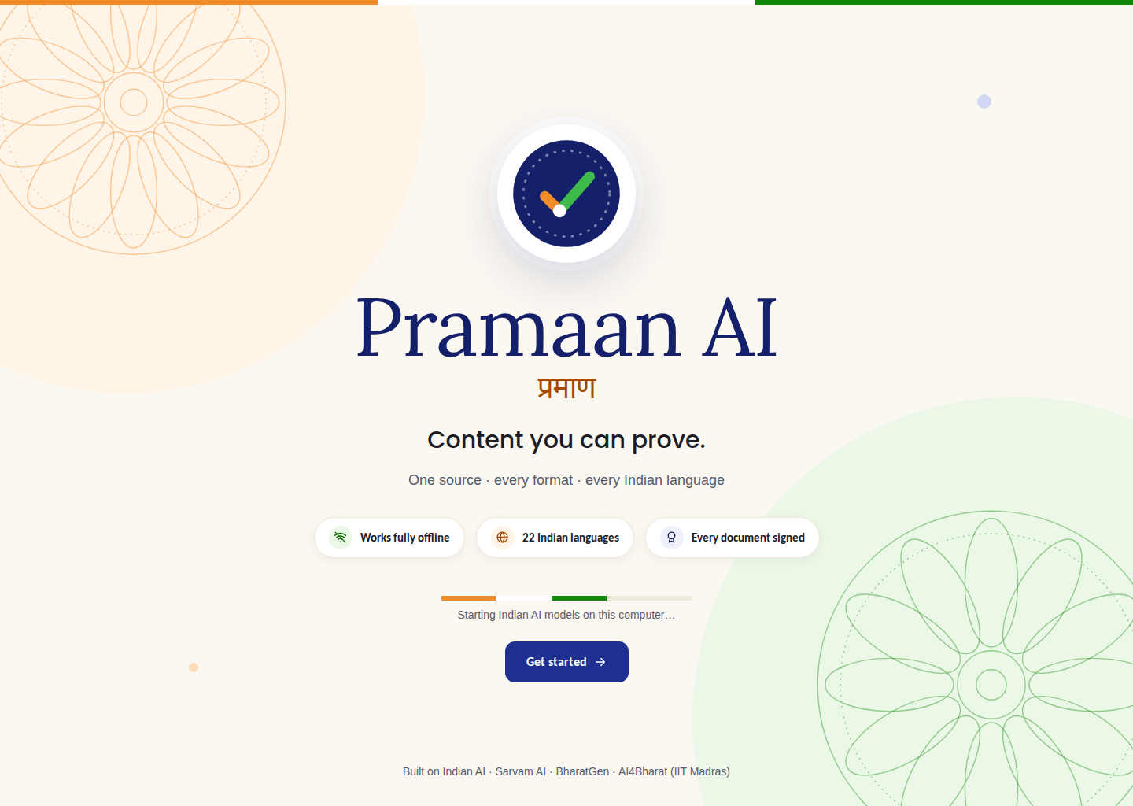
Screen 01: Splash screen
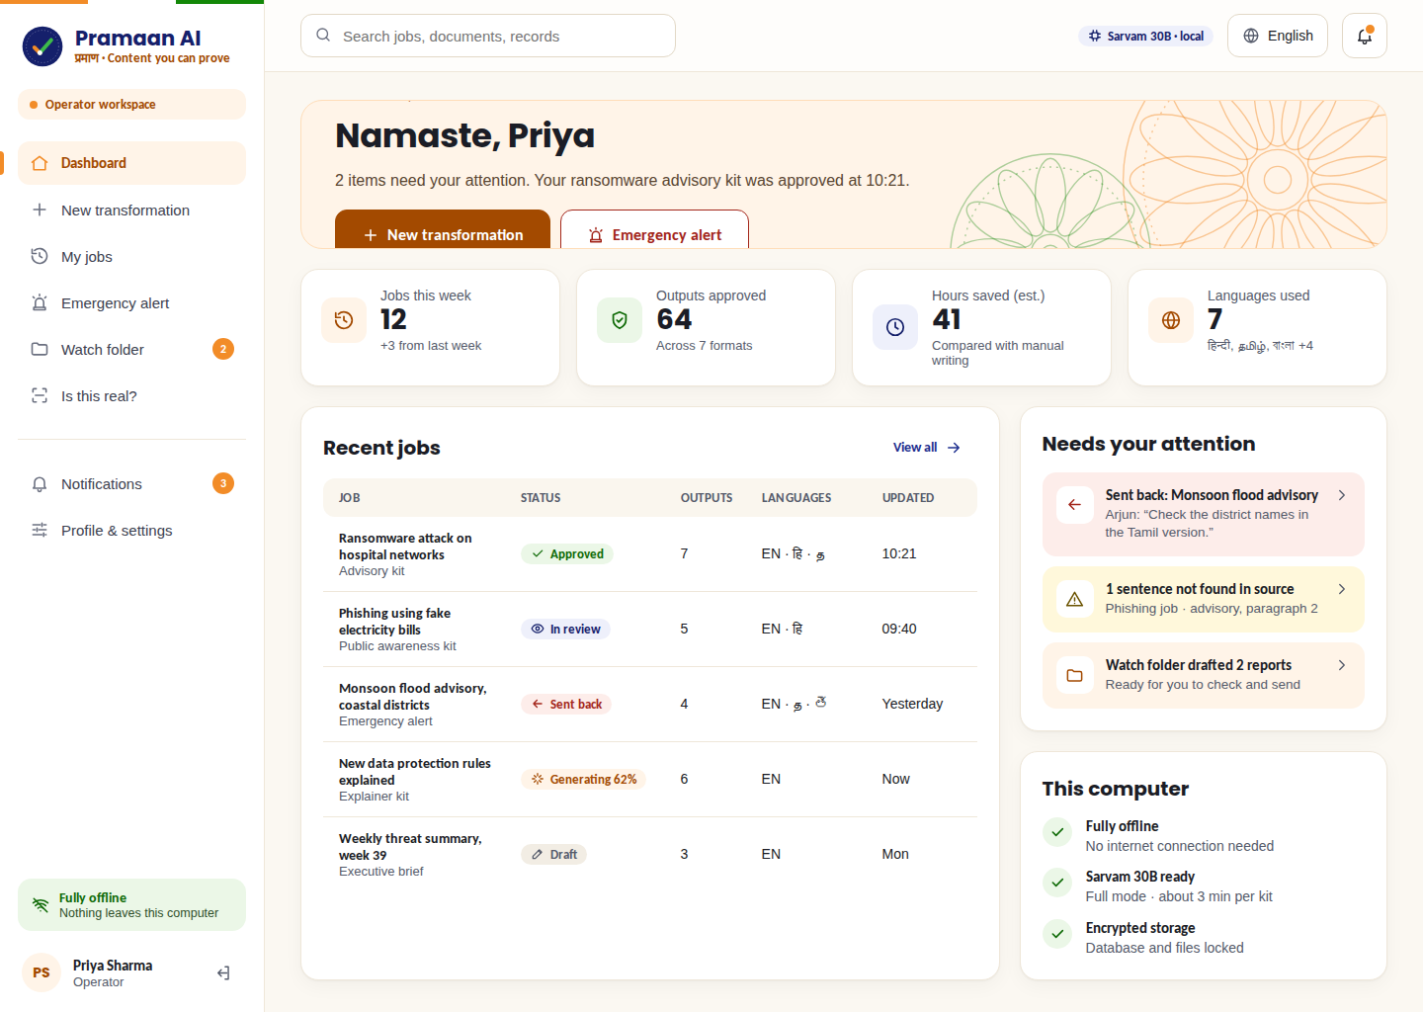
Screen 08: Operator dashboard
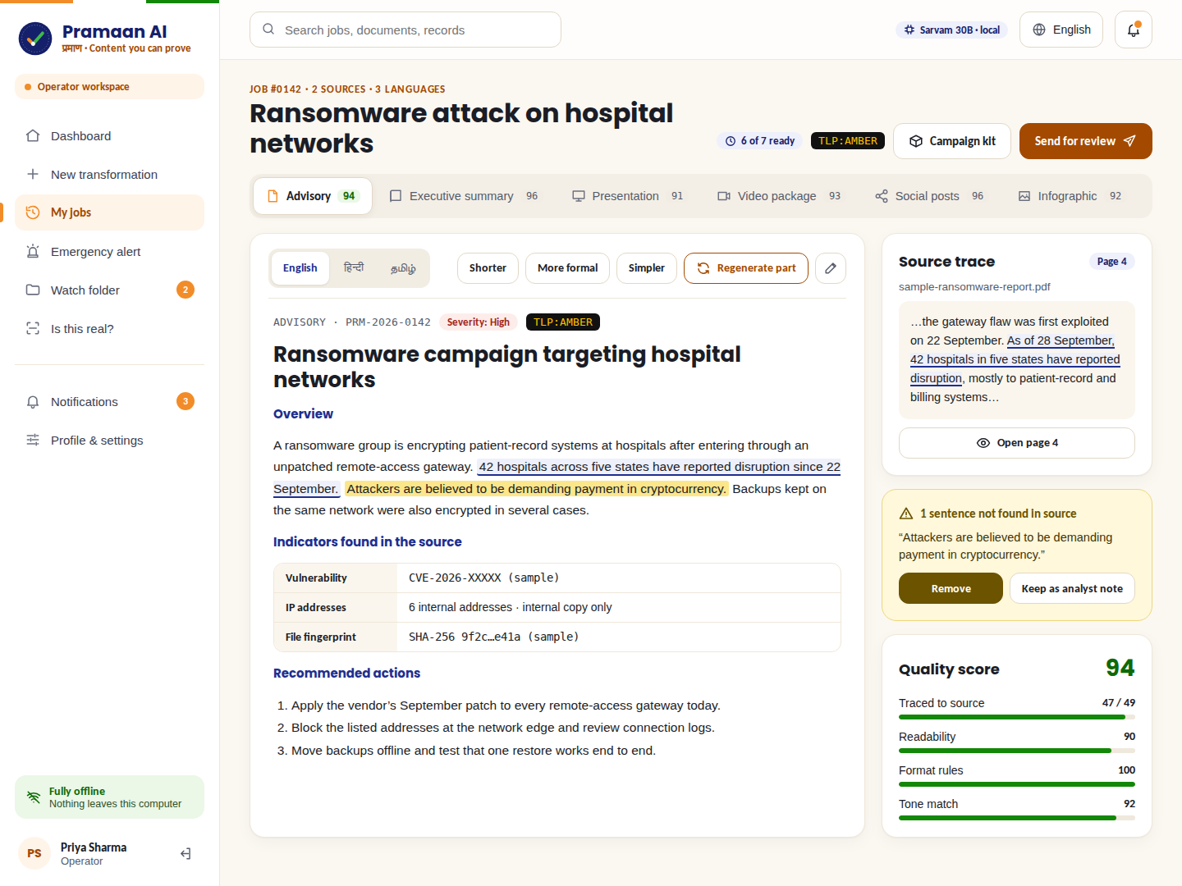
Screen 13: Results with source trace and the yellow “not found in source” warning
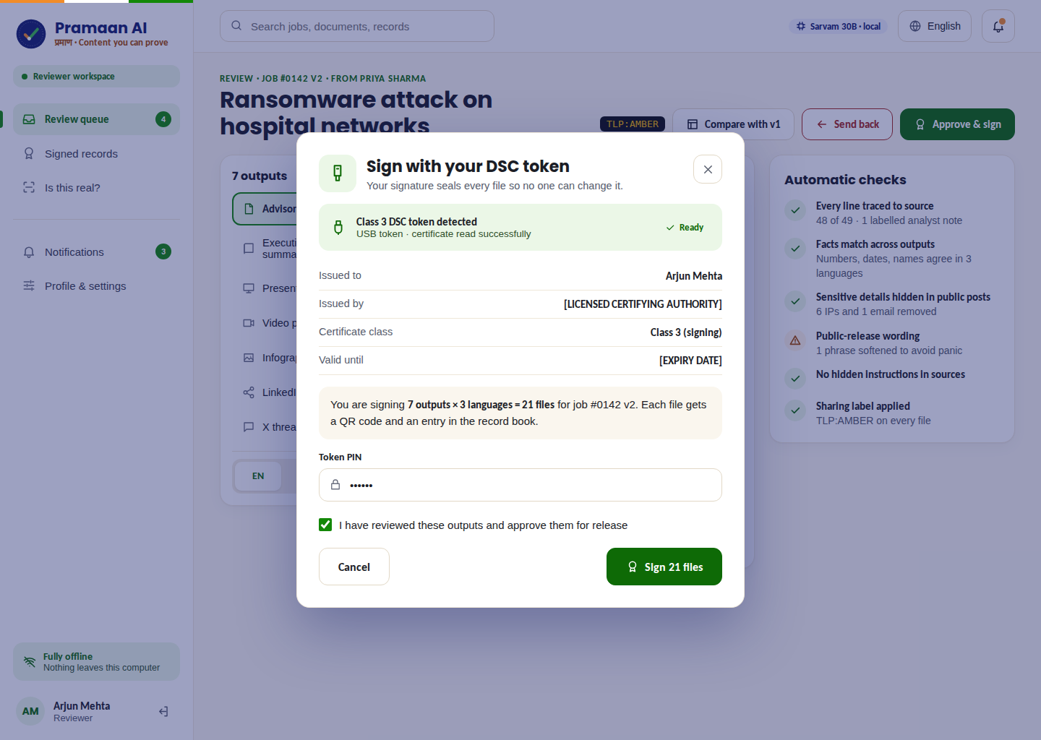
Screen 26: Reviewer signs with a DSC token
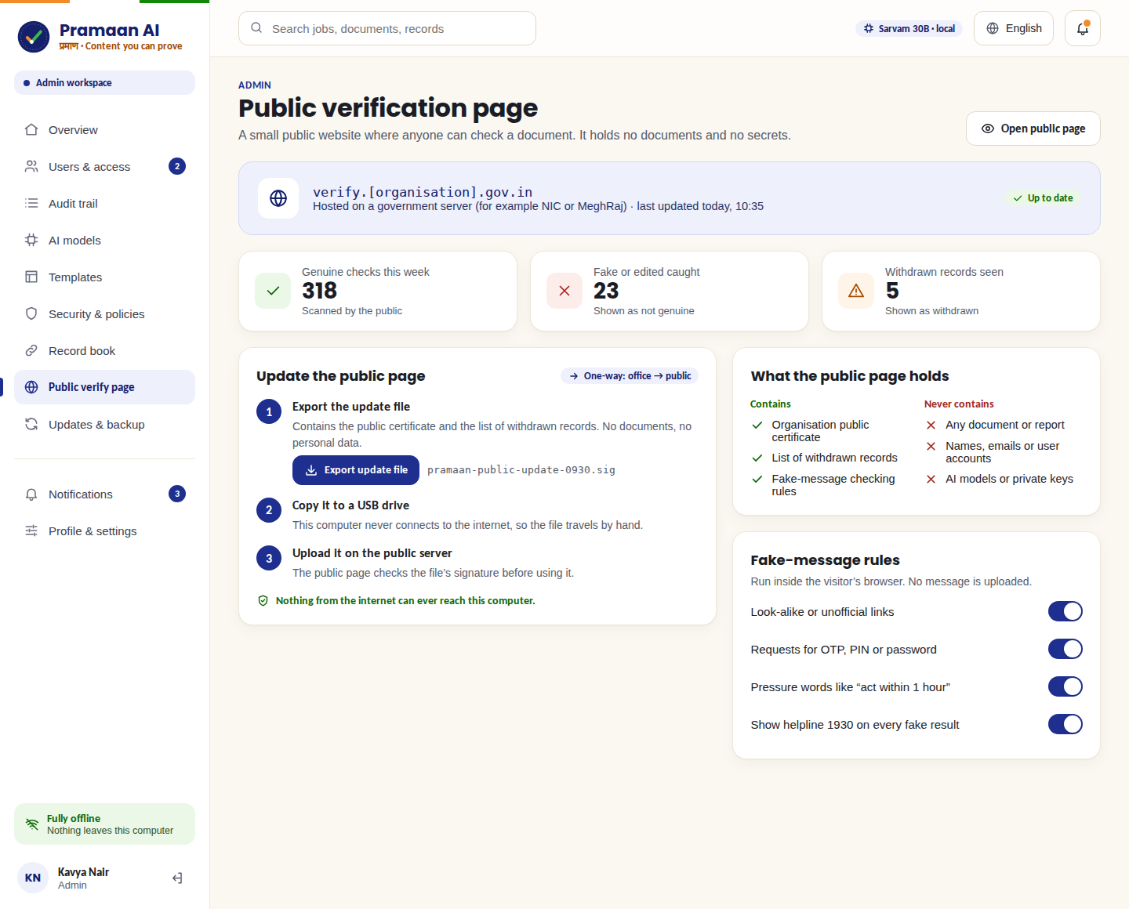
Screen 38: Admin keeps the public verify page up to date
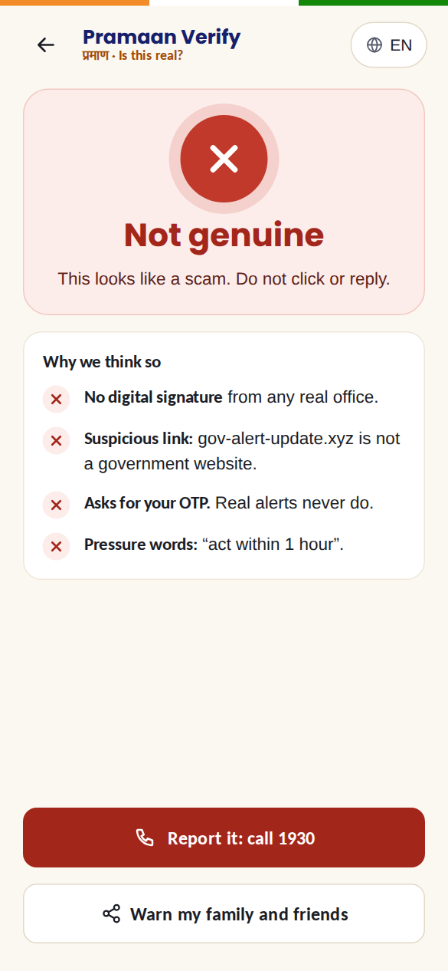
Screen 46: A citizen’s phone showing a fake alert

8. Technology stack

8.1 The big picture
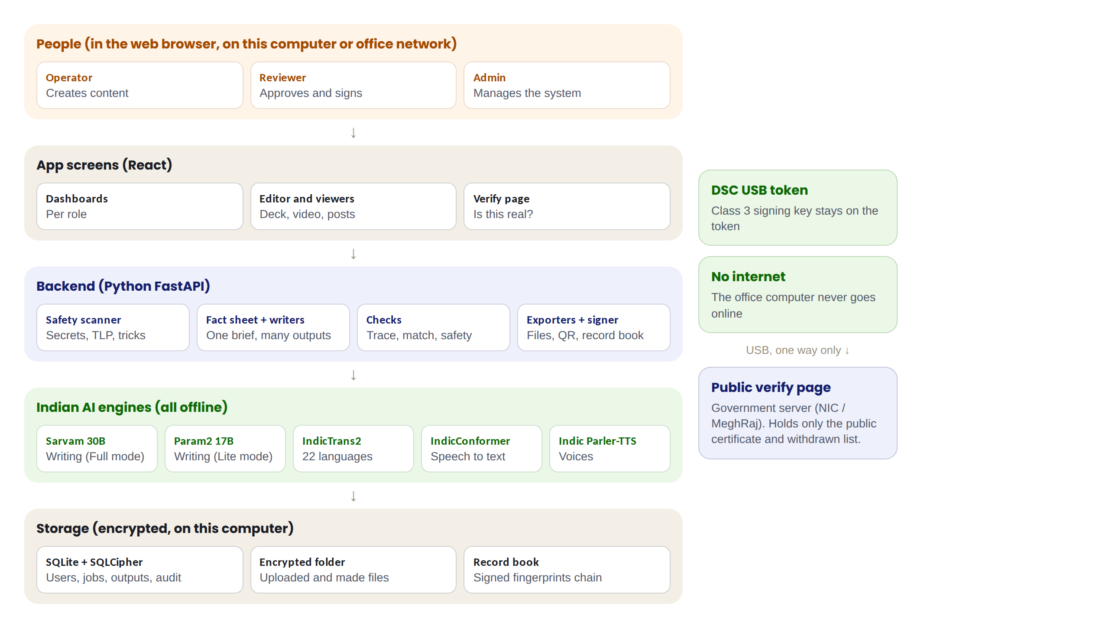
Figure 3: How the parts of Pramaan AI fit together
Think of it as five layers, from top to bottom: the people using a browser, the screens, the backend (the hidden “kitchen” where work happens), the Indian AI engines, and the encrypted storage. Everything sits on one computer (or one office server). Only a tiny public page lives outside, and it gets updates one way by USB.

8.2 Indian AI and language technology
Job | Technology | Made by | Notes
Main writing AI (Full mode) | Sarvam 30B | Sarvam AI, Bengaluru | Open source (Apache 2.0). Mixture-of-Experts: about 2.4B of 32B parameters active per word, so it is fast. 65K-token memory. Official offline version available.
Lite writing AI | BharatGen Param2 17B | BharatGen, IIT Bombay | For computers with less memory. Released under a BharatGen non-commercial licence, so check terms before any commercial use.
Translation (22 languages) | IndicTrans2 | AI4Bharat, IIT Madras | Open source, runs offline, covers all 22 scheduled languages.
Speech to text (Indian languages) | IndicConformer | AI4Bharat, IIT Madras (Bhashini mission) | Runs offline, even on a normal processor.
Voice narration | Indic Parler-TTS | AI4Bharat, IIT Madras | Natural Indian-language voices, offline.
Digital signature | Class 3 DSC (CCA framework) | Indian certifying authorities | Signing key stays on a USB token.
Online mode (optional) | Bhashini, Sarvam APIs | MeitY, Sarvam AI | Only if an organisation allows internet; not needed for the core app.

8.3 App technology
Part | Technology | Why
Screens (frontend) | React with TypeScript | Modern, fast, reusable screens
Backend | Python with FastAPI | Python is the language of AI tools; FastAPI is simple and fast
Running the AI | llama.cpp server (or Ollama) | Runs Indian models offline, with 4-bit compression and prompt caching
Database | SQLite encrypted with SQLCipher (PostgreSQL for large offices) | A single encrypted file; no database server needed
File storage | Encrypted folder on disk | Uploads and outputs stay locked
Reading documents | PDF and Word readers; Tesseract OCR for scans | Handles every common input
English speech | Whisper (open source) | For English audio in videos
Making files | python-pptx, python-docx, PDF generator, Pillow | Real PowerPoint, Word, PDF and PNG files
Video preview | FFmpeg | Joins scenes, narration and subtitles into an MP4
Signing and fingerprints | SHA-256 hashing, PKCS#11 for the DSC token, QR code library | Standard, trusted security building blocks
Public verify page | Plain HTML and JavaScript (Web Crypto) | Tiny, fast, works on any phone, holds no secrets
Office network (optional) | Caddy web server with HTTPS | Secure access for a whole team

8.4 Why not Firebase any more
Our earlier projects used Firebase, which is Google’s online cloud. A fully offline app cannot depend on any online service, so Firebase is replaced by a local encrypted database and local login. We still reuse our experience with role-based access, dashboards, voice features and the danger-word detector from our mental-health project, which becomes the sensitive information scanner.

8.5 An honest note on “everything Indian”
The AI brain, the language tools, the signature system and the standards are Indian. A few supporting tools are global open-source projects (llama.cpp, SQLite, Tesseract, Whisper, React, Python), because there are no mature Indian alternatives for them. These run offline on the user’s computer, so data still never leaves India. This is the same approach Indian government systems use.

8.6 How we make it fast
- Mixture-of-Experts model: Sarvam 30B uses only a small part of its parameters for each word.
- 4-bit compression: a smaller model file that runs faster with almost the same quality.
- Read once, reuse (prompt caching): the fact sheet is loaded into the AI’s memory once and reused for every output.
- Quick mode vs think mode: deep reasoning only where it matters.
- Keep the model loaded, stream text, short outputs first, remember past results.
- Lite mode for weaker computers.

8.7 Main database tables
Table | What it stores
users | Name, employee ID, role, division, password (safely scrambled), DSC holder or not
jobs | Each transformation: title, owner, status, TLP level, version
sources | Details of uploaded files and their fingerprints (the files themselves are in the encrypted folder)
fact_sheets | Key facts with the exact source location of each fact
outputs | Each generated output, per language, with quality scores
reviews | Comments, approvals and send-backs
records | The record book: fingerprint, signer, time and the previous record’s fingerprint
audit_log | Every action, linked in a chain so it cannot be edited
templates, settings | Letterheads, designs, security rules and preferences

8.8 Project folder structure
Folder | Contains
frontend/ | React screens for all roles
backend/ | FastAPI app: routes, safety scanner, fact sheet, writers, checks, exporters, signer
backend/prompts/ | One prompt template per output type
models/ | Downloaded Indian AI model files (not in Git)
verify-page/ | The small public verification website
scripts/ | install.sh, start.sh, update and backup scripts
docs/ | README, architecture document, demo script

9. How Pramaan AI is downloaded, installed and used

9.1 Computer needed
 | Full mode | Lite mode
Writing AI | Sarvam 30B | Param2 17B
Memory (RAM) | 32 GB recommended | 16 GB
Graphics card | Optional, makes it much faster | Optional
Free disk space | About 60 GB (estimate; the Sarvam 30B 4-bit file alone is roughly 20 GB) | About 35 GB (estimate)
Operating system | Linux (Ubuntu, BOSS Linux); macOS for development | Same

Important: These numbers are estimates. The team must test on its own laptops early, because model sizes and speeds vary.

9.2 Option A: install with internet (one time)
Open the terminal and type:
Command | What it does
git clone https://github.com/[team]/pramaan-ai | Downloads the app code
cd pramaan-ai | Opens the app folder
./install.sh | Installs everything, downloads the Indian AI models, creates the encrypted database and the first Admin

Internet is needed only for this one-time download.

9.3 Option B: fully offline install from USB
For secret offices with no internet at all, the app and the AI models are copied onto a USB drive or hard disk. On the office computer, run ./install.sh --offline. Nothing is downloaded from the internet.

9.4 Everyday use
- Type ./start.sh in the terminal (or double-click the Pramaan AI icon).
- The app opens in the web browser at http://localhost:8080. “localhost” means “this computer”, so nothing goes online.
- Sign in and work as normal.

9.5 For a whole office (office server)
Install Pramaan AI on one strong computer in the office. Team members open it from their own desks over the office network, for example at https://pramaan.office.local. A small web server (Caddy) adds a secure lock (HTTPS). The office still needs no internet.

9.6 Updates and backups
Updates arrive as a signed package on USB. The app checks the signature, backs everything up and then installs the update. Encrypted backups can run every night to a USB drive.

9.7 The public verify page
The small verify website is placed on a government server (for example NIC or MeghRaj). It contains only the public certificate and the withdrawn list. The Admin updates it with a signed file carried by USB. For the hackathon demo, the verify page can run from a laptop’s Wi-Fi hotspot so judges can scan a QR code with their phones.

10. Security and privacy
Risk | How Pramaan AI protects against it
Secret reports leaking online | Fully offline; the office computer never connects to the internet
A stolen laptop | Database and files are encrypted; nothing is readable without the password
Secrets appearing in public posts | Sensitive information scanner plus automatic hiding in public outputs, controlled by TLP
AI making things up | Fact sheet, self-check, click-to-source and yellow warnings; a human always approves
Hidden instructions inside files (prompt injection) | Hidden-instruction shield scans text and images before the AI sees them
Fake government advisories | DSC signatures, QR codes, record book and the public “Is this real?” page
Someone changing a signed document | Its fingerprint stops matching; the verify page shows “Not genuine”
Someone secretly editing old records | Each record includes the previous record’s fingerprint, so the chain breaks
Stolen signing key | The key stays on the DSC USB token and needs a PIN
Misuse by an insider | Roles limit what each person can do; every action is in the audit trail

10.1 Laws and standards we follow
- DPDP Act 2023 (India’s data protection law): personal data never leaves the device.
- IndiaAI Mission: uses India’s own AI models.
- CCA framework: Class 3 digital signature certificates.
- CERT-In style advisory structure.
- TLP 2.0 (Traffic Light Protocol) sharing labels, used worldwide by security teams.
- GIGW (Guidelines for Indian Government Websites) for accessible, clear screens.

11. Build plan and demo

11.1 Build in this order
Phase | What we build | Done when
0. Setup | Accounts, laptops, download models, test Sarvam 30B speed | The model answers a test question on our laptop
1. Core engine | Upload → fact sheet → 7 outputs → file export | One report produces all 7 files
2. Trust | Click-to-source, self-check, fact match, quality score | Unsupported sentences turn yellow
3. Security | Scanner, TLP, auto-hiding, hidden-instruction shield | Public posts hide test IP addresses
4. Anti-fake | Signing, QR codes, record book, verify page, “Is this real?” | An edited copy shows “Not genuine”
5. Languages and voice | IndicTrans2, Indian voices, speech input | Hindi and Tamil outputs with narration
6. Roles and screens | Login, three roles, dashboards, admin screens | The full flow works end to end
7. Extras | Emergency mode, watch folder, version compare, templates | Only if time allows
8. Deliverables | README, 2-page architecture document, 2-minute video, 5 slides | Everything submitted

Rule: Build the core first and make it work perfectly. Anything unfinished goes on a “Future roadmap” slide. Judges see that as vision, not missing work.

11.2 The 2-minute demo
- Hook (0–10 s): turn Wi-Fi off on screen, drop in a real public CERT-In advisory, tick all outputs.
- Speed: summary and posts appear in seconds; show the deck, the video preview and the Hindi version.
- Truth: click a sentence to show its source; show a yellow warning.
- Safety: paste text with “RESTRICTED” and an IP address; show the warning and the hidden details in the public post.
- Proof: sign with the DSC token, scan the QR with a phone: “Genuine”. Change one word: “Not genuine”.
- Close: paste a fake WhatsApp alert into “Is this real?”: caught.
Always record a perfect “golden run” before the demo, and keep it ready in case anything goes wrong live.

12. Honest limitations and future roadmap

12.1 Limitations to be aware of
- Offline AI on a laptop is slower than cloud AI; a full kit may take a few minutes.
- Local models write slightly less fluently than the biggest global models; the fact sheet, self-check and human review make up for this.
- Voice quality and coverage must be tested for each Indian language.
- The public verify page is only as up to date as the last USB update.
- Translations of sensitive messages should always be checked by a native speaker before release.

12.2 Future roadmap
- Anchor record-book fingerprints to a permissioned national blockchain.
- A mobile app for QR verification.
- Training a custom model on an organisation’s past advisories.
- Direct publishing to official portals after approval.
- Detection of deepfake images and videos.

13. Simple glossary
Term | Simple meaning
AI model / LLM | The “brain” that reads and writes text
Offline / air-gapped | Works with no internet connection at all
Fact sheet | Our list of key facts that every output is written from
Hallucination | When AI confidently writes something false
Grounding / source trace | Proving where each sentence came from
Prompt injection | Hidden text in a file that tries to trick the AI
PII | Personal information such as Aadhaar, PAN, phone numbers
TLP | Traffic Light Protocol: Red, Amber, Green, Clear labels for who may see something
Hash / fingerprint | A unique code for a file; changes completely if one character changes
Record book / hash chain | A list where each entry contains the previous entry’s fingerprint, so secret edits are exposed
DSC | Digital Signature Certificate, an official digital seal kept on a USB token
QR code | A square code a phone camera can read
OCR | Reading text from a picture of a page
TTS / STT | Text-to-speech (computer speaks) / speech-to-text (computer types what you say)
Mixture-of-Experts (MoE) | An AI design that uses only a small part of its brain for each word, so it runs faster
4-bit compression (quantization) | Making the AI file smaller so it runs faster on normal computers
localhost | “This computer”: the app runs on your own machine
API key | A password that lets a program use an online service

